Purdy Elementary
Science Fair Handbook
March 10, 2016

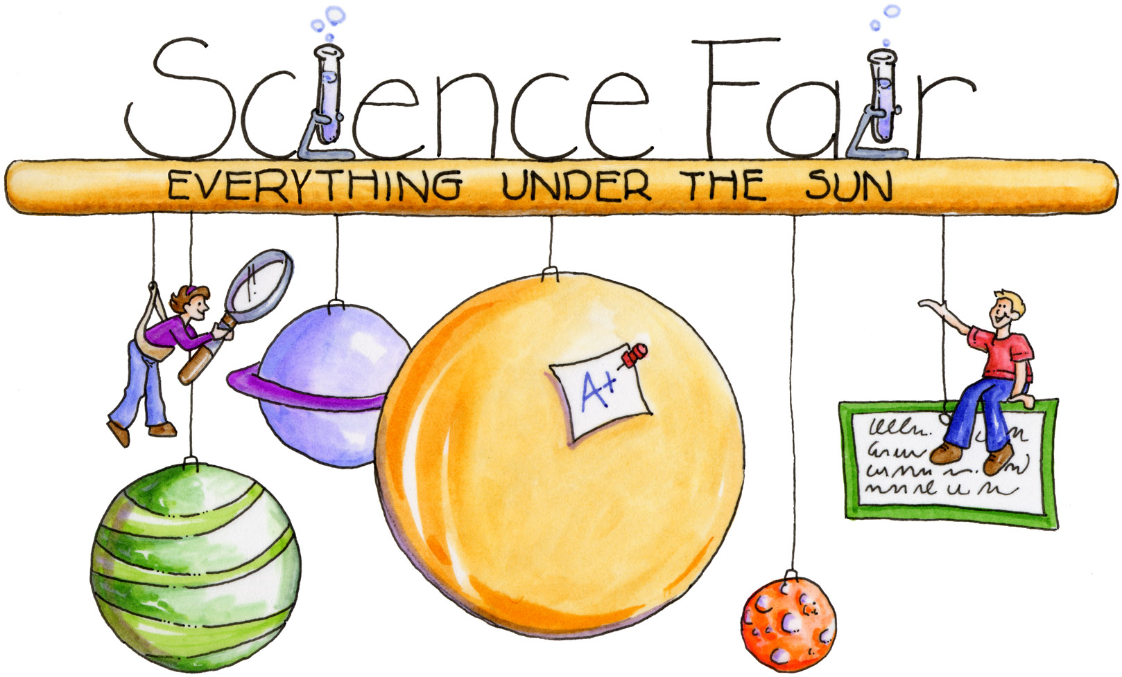

Refer to this packet to complete your Science Fair Project! When finished,
neatly re-write or type each section to glue on your final display board.
This year’s Science Fair is optional & will not be graded for concepts.

NAME: __________________________________ TEACHER CODE: ______
(first and last name)

THE SCIENTIFIC METHOD
The scientific method is a blueprint of a controlled science experiment in which you will participate in for your science fair project. Here are two great websites that provide helpful information regarding the scientific method:
http://www.sciencebuddies.org/science-fair-projects/project_guide_index.shtml?From=Tab
http://www.jpl.nasa.gov/education/videos/playVideo.cfm?videoID=38

- Pick a topic: This step gives your experiment a purpose. Pick out a topic that interests you and determine why you want to do the experiment.

i.e. I notice that gardeners use fertilizer/plant food when they are working in their gardens.

- Investigative Question: Put your topic into a testable question that will be answered. Make sure you include the manipulated & measured variables.

i.e. – What type of plant food will grow the tallest bean plants?

- Background Research: What do you know about your topic? What can you look up? Do you have a personal connection to the topic?

- Hypothesis: Make a prediction (or a guess) as to what you think the answer to your investigative question is. This is your hypothesis. You must do this before you begin your experiment! Make sure you back up your prediction with a reason or explanation as to why you think you are correct. This part normally begins with the word because.

i.e. - I think that Miracle Grow will grow the tallest bean plants, because it has the most nitrogen. Nitrogen is an important nutrient that plants use to grow.

*Important Note: A hypothesis doesn’t have to be right for the experiment to be successful. We can learn just as much from our scientific failures as our successes.

- Experiment: This is what you will do to prepare for your science fair project.
- Diagram: A labeled drawing or photo of how you are setting up your experiment.
- Tools: What tools you will need to measure the experiment.
- Materials: What supplies you will need to conduct the experiment.
- Variables: The one thing you manipulated (or changed). What you recorded (or measured). Everything else that you controlled (or kept the same).
- Procedures: The step-by-step process that you will follow for each variable tested. Don’t forget to perform 3 tests!

- Observation & Data Collection: Perform the experiment! Make sure you measure and record your data, as well as other notes. You can even take photographs during the experiment. Display your data in a table or graph, and provide pictures or photographs, or a combination of these on your final project. Include averages for each variable tested!

- Analysis: Examine your results to look for patterns or tends.

- Conclusion: Present your data. Include information for these four areas:
- Answer the investigative question
- Explain your highest and lowest data (i.e. farthest, highest, tallest vs. shortest, smallest, etc.)
- Find the difference between your highest and lowest data
- Explain how the data supports the answer to your investigative question

PARENT INVOLVEMENT
Parents’ involvement in their child’s science fair project should be a positive experience for both parents and their children. Parents should guide their students without actually doing it for them. This is your child’s project and they will have a greater feeling of pride if they know that they did it on their own. Hard as it might be, students learn best when they learn from their own successes and failures. Remember this is a learning experience for your child. Failure does not mean a lack of learning or insight.

Here are some positive ways in which a parent can help their child:

BE INFORMED: Read the material in this handbook. Check out the information on the Purdy Science Specialist website (http://purdypantherscience.weebly.com/) for updates regarding the Science Fair. Become familiar with the Scientific Method.

PICKING OUT THE TOPIC: Guide your student in picking out a topic without actually picking it out for them. The project will be more meaningful if the idea comes from your child. How-ever, you may want to point out the limitations of experiments that may be too difficult to do based on either time restraints or the limitations caused by space, climate or other external factors. You may also want to guide them if they have picked out a topic that is too broad. If you get stuck, please contact the science specialist teachers, they’ll be happy to help.

HELP YOUR CHILD ORGANIZE HIS/HER TIME: Your job is to help your child organize his/her project. This year, we have included “complete by dates” in the science fair rough draft handbook. These dates are simply guidelines to help your child stay on track to complete a quality Science Fair Project. Remember the experiment might take several weeks (or just 2 hours) to complete. The display itself also takes some time to put together.

CONDUCTING THE EXPERIMENT: After your child has carefully planned the experiment they will do, make sure your child has all their supplies they will need. Offer support if things don’t work out and encourage them to try again perhaps in a different way. Brainstorm ways to revise the experiment if needed.

SAFETY FIRST: You may need to supervise certain experiments, especially if heat or sharp instruments are used.

COMPLETION OF PROJECT: Your student might need your “eye” to proofread their final display one last time before the Science Fair (March 10th).

MAKE IT FUN: This project should be fun for your child. Take pictures as they work at home so you have a record of your child’s emerging independence as a learner. Remember, an experiment doesn’t have to “work” for the project to be successful. As long as your child is learning, even if it is from mistakes, it is a worthwhile project.

Science Fair Display Board
In an effort to standardize the display boards, please use the following example for how to set up the steps of the Scientific Process on your board.

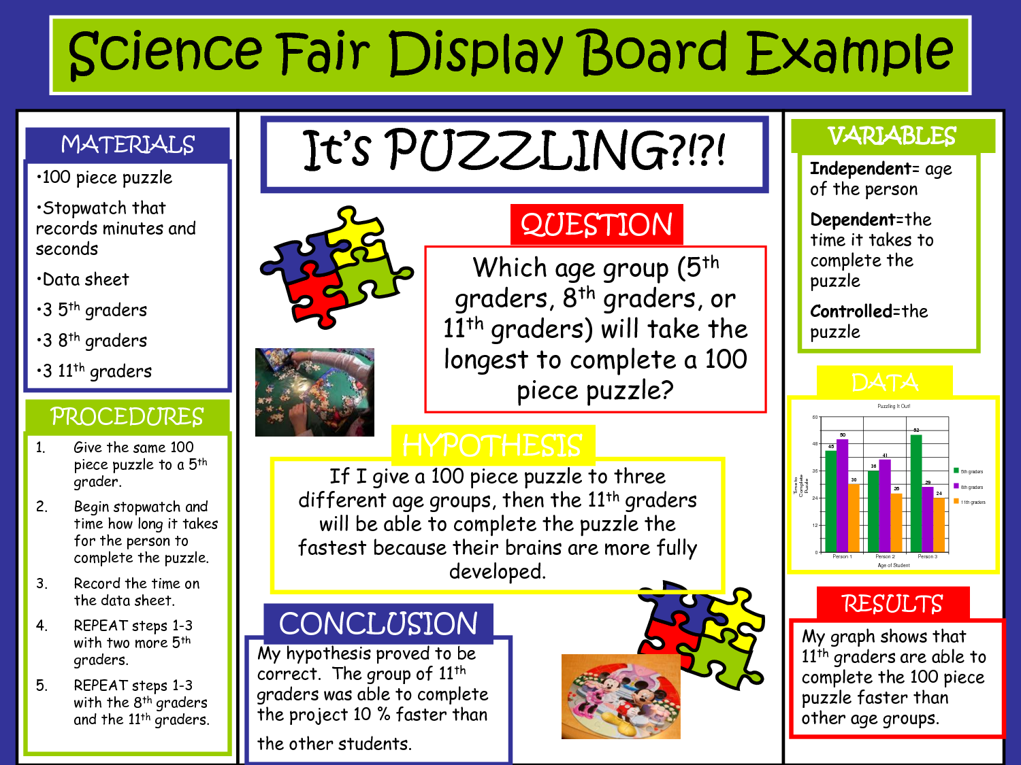

PLEASE NOTE:
- Include your background research after you state your investigative question.
- Before stating your materials, include the tools that you used during the experiment.
- Be careful with what information you decide to display. Less is some-times more!

Below are great examples from a previous Purdy Elementary Science Fair:

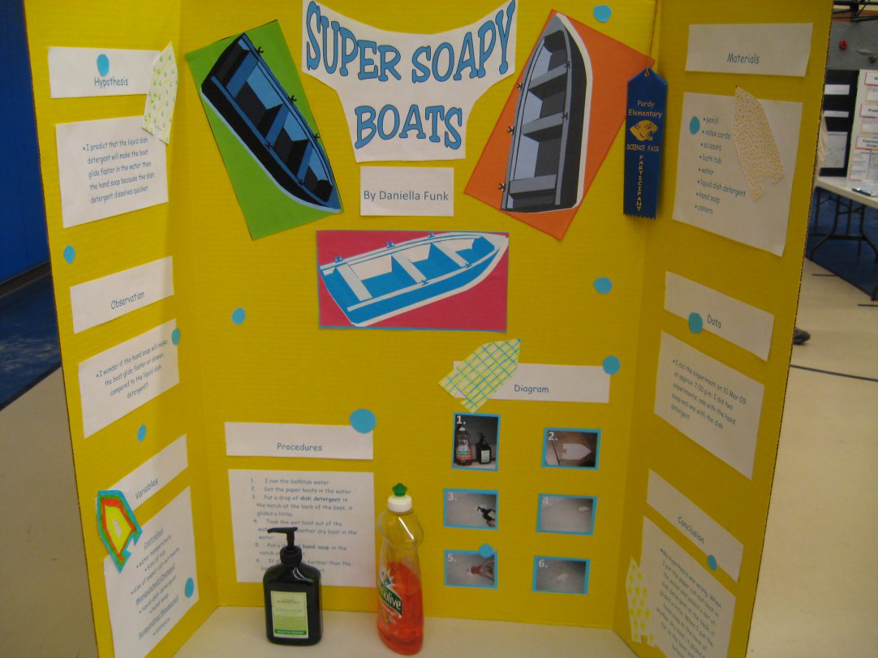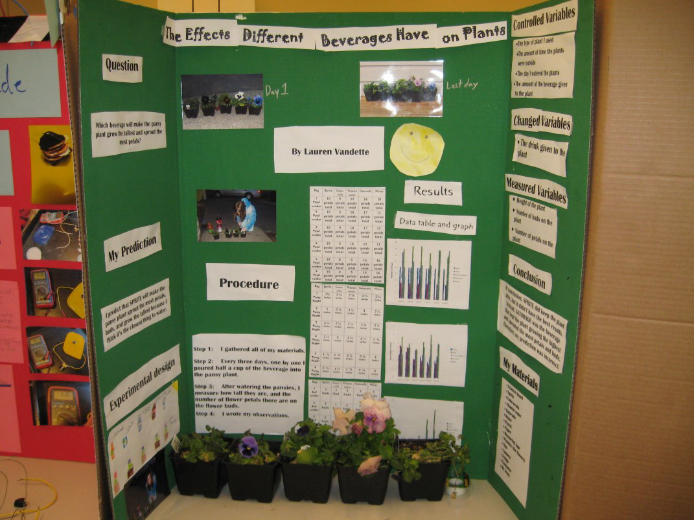

Science Fair Rough Draft Packet (does not need to be turned in)
NAME: ____________________________________ TEACHER CODE: ____________

1. Investigative Question: Complete this section by January 21st. Don’t forget to bring your completed Registration Form (attached at the end of this booklet) and hand it in to Ms. Troyer by January 28th.

2. Background Research: What did you find out about your topic that will help you make an informed prediction? Use additional paper if you need more room.

3. Hypothesis: Make a prediction after doing some background research.

4. VARIABLES IN MY EXPERIMENT: Complete this section by February 4th.
Manipulated/changed variable (only one):

Recorded/measured variable (only one):

Controlled variables (many – list at least 3 here):

Set Up, Materials & Procedures: Complete this section by February 11th.
5. Diagram: Draw a diagram and label it to show how you set up your experiment.

Your drawing should be simple and easy to read.
6. Tools & Materials: What was needed to do your experiment – List all tools & materials!

7. Procedures: What steps do you need to complete your experiment? Be specific and include when you need to record data. Don’t forget to include 3 trials!

8. Results, Data & Observations: Complete this section by March 3rd to give you enough time to write up your conclusion and make your presentation board. Presentation boards will be displayed in the gym on March 10th. → Please look for more information regarding the Science Fair Open House & when/how to bring your child’s presentation board to school.
Use this space to make a T chart, write notes about your observations, or make a rough graph. If you need more space, attach additional pages.

9. Conclusion: In your conclusion include:
a. Answer your original investigative question. Be obvious! What did you learn from doing your experiment?
b. Include evidence – in sentence form. Write about both the highest and lowest data from your experiment. Find the difference of the high and low data. Finally, explain how the data supports the answer to your investigative question.

10. Acknowledgements: Whom would you like to thank for helping you with your experiment? Write that here!

